DELIGHTFUL RUSSIA

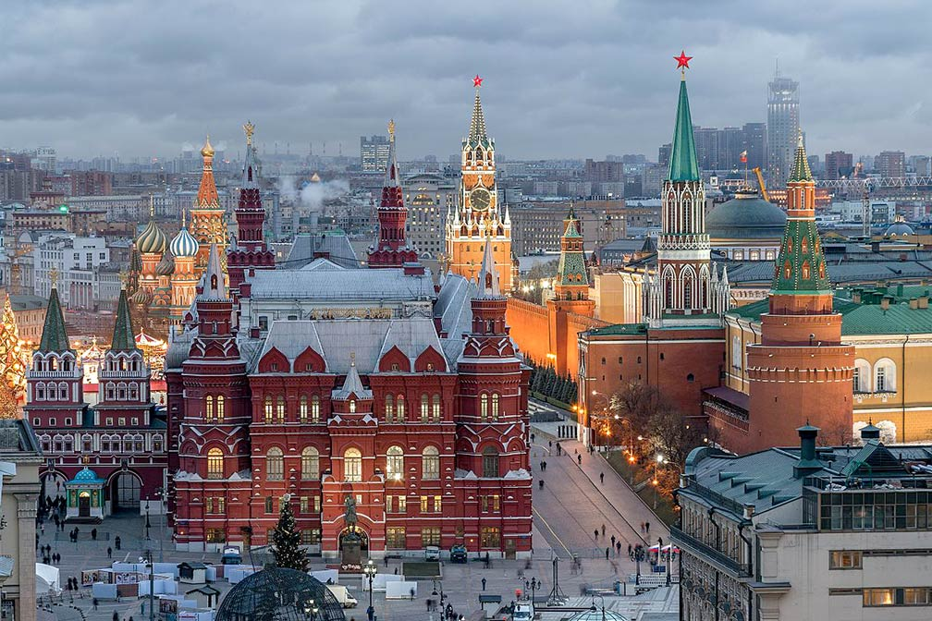

DAY 1 MOSCOW
- Arrival at Airport transfer to Hotel
- Lunch
- Check in to the hotel
- Dinner
- Over night at Hotel
- Transfer with Guide

DAY 2 MOSCOW
- Breakfast at Hotel
- AM: Panoramic city tour: Lenin's Tomb (outside, Red Square, Sparrow hills,
Moscow State University, Victory park,
- Lunch
- Metro Tour + Shopping trip
- Dinner
- Over night at Hotel
(Vehicle & Guide 1000-2100)

DAY 3 MOSCOW

- Breakfast at Hotel
- Kermlin
- Lunch
- Arbat Street + Avia Park Mall
- Dinner
- Over night at Hotel
(Vehicle & Guide 1000-2100)

DAY 4 MOSCOW

- Breakfast at Hotel
- Cosmos Museum
- Lunch
- Moscow River Cruise
- Dinner
- Over night at Hotel
(Vehicle & Guide 1000-2100)

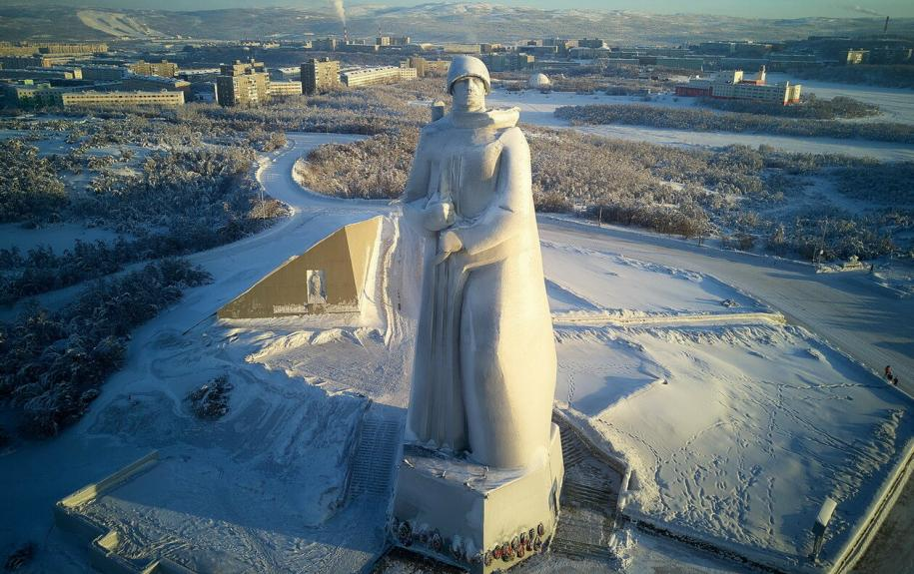

DAY 5 MOSCOW- MURMANSK

- Breakfast at Hotel
- Checkout from Hotel transfer station for sapsan train to St. Petersburg
- Lunch
- Meet a guide with a car or a minibus. Excursion in the city center, watching city life. The guide tells the history of the city and show a lot of specialties connected to events happened for past 100 years. Come to a harbour to see merchant and fishing ships. Visit the first nuclear icebreaker “Lenin”. One of highlights of the city is Second World War Memorial “ALESHA” which can be reached by public transport and by foot. The majestic monument for The Defenders of the Arctic was installed on a high hill above Murmansk in 1974 in memory of the War; a figure of a watchman with a rifle of a height of 34 meters, which is visible almost from any point of the city. The best place to make panoramic photos of the city and harbours.
- Dinner
- Over night at Hotel
(Vehicle only for transfer)

DAY 6 MURMANSK

- Breakfast at Hotel
- Day tour of the Arctic Ocean coast, Teriberka village. The tour starts from Murmansk through the endless tundra with crystal clear lakes and rocks. Reach in the village of Teriberka, Which is located on the shores of the Arctic Ocean. Learn the history of this place, its everyday life. Enjoy beautiful views of Barents Sea and a magnificent waterfall that flows into the Arctic Ocean. Try to build pyramid of stones for luck. Feel freezing wet atmosphere of Barents sea. Take photos of snowy mountains. Moreover, you will be able to take part in building statue of local policeman and his car. Back to hotel.
- Late evening have dinner & again transfer to witness the most thrilling experience of your life….hunting for Northern Lights. Late back to hotel.
- Dinner
- Over night at Hotel
(Vehicle & Guide 1000-2100)

DAY 7 MURMANSK- SAINTPETERSBURG

- Breakfast at Hotel
- Checkout from Hotel transfer airport for flight to St. Petersburg
- Lunch
- Check-in to the hotel
- Dinner
- Overnight at Hotel
(Vehicle only for transfer)

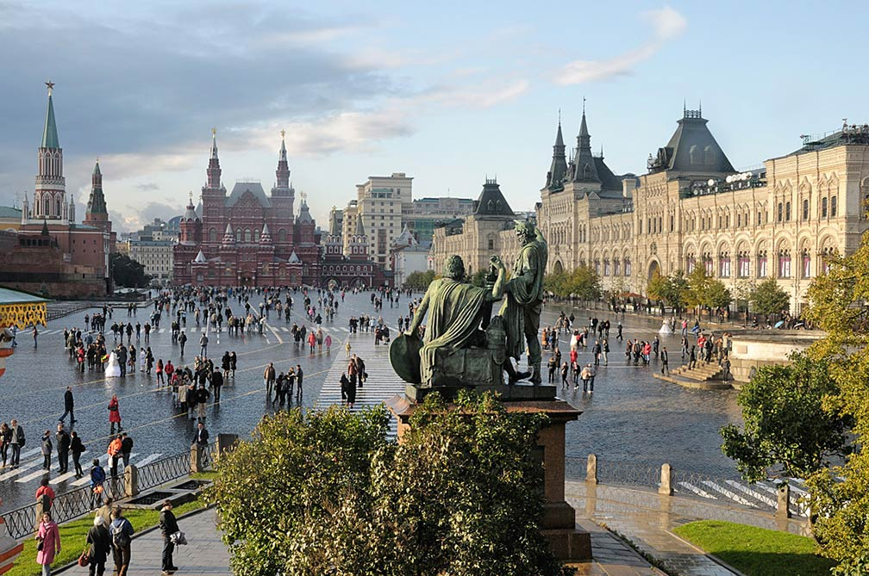

DAY 8 SAINTPETERSBURG

- Breakfast at Hotel
- City tour: State Hermitage Museum (outside), the Admiralty (outside), St.Isaac's Cathedral (outside), Fine Arts Square, Church of Resurrection on Spilled Blood, Smolny Cathedral, Bronze Horseman
- Lunch
- Kazan Cathedral
- Dinner
- Over night at Hotel
(Vehicle & Guide 1000-2100)

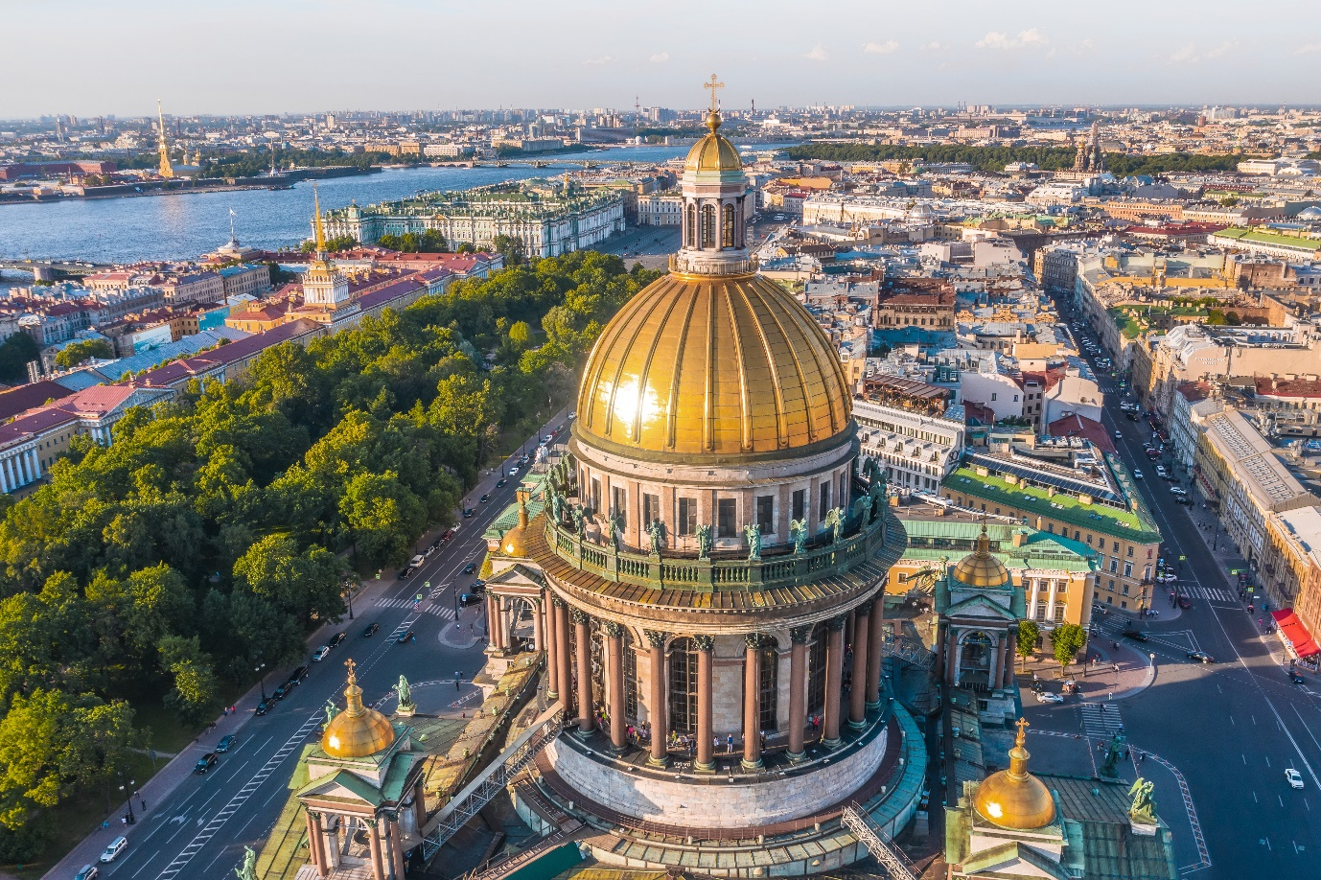
DAY 9 ST. PETERSBURG

- Breakfast at Hotel
- Hermitage Museum
- Lunch
- Neva Canal Cruise
- Dinner
- Over night at Hotel
(Vehicle & Guide 1000-2100 PM)

DAY 10 SAINTPETERSBURG-ONWARD

- Breakfast
- checkout from hotel transfer to airport for onward destination
Transfer without Guide

