VIETNAM DETAILED ITINERARY

Day 1: Arrival + Explore + free & easy (D)

Pick-up and transfer to the hotel. After free & easy.

Day 2: Halong Bay overnight cruise (BLD)
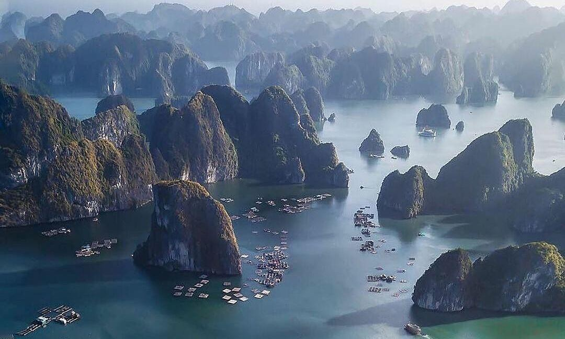

08.00 – 8.30 Leave Ha Noi city for Ha Long International Cruise Port in Bai Chay town, Ha Long city. Refresh up at the lounge.

12.00 – 12.30 Embark Oriental Sails. Enjoy welcome drink and get a brief introduction about cruise and safety guidelines. Check-in your cabin.

13.15 Have lunch while cruising in the magnificent Ha Long Bay, admiring the fascinating nature, then anchor at Titop Island area.

15.00 – 16.00 Join a guided visit to Sung Sot Cave (also called Amazing Cave), one of the biggest and the most beautiful cave in Ha Long Bay.

16.00 – 17.00 Climb to the peak of Titop Island for the panorama view of the bay. Going down and relaxing on the beach, swimming in the crystal water.

17.20 Return Oriental Sails, enjoying the sunset while relaxing with Happy hour from now to dinner time at the bar.

18.00 Enjoy happy hours with various drinks on discounts. Take part in a cooking demonstration and food décor with our Chef

19.00 – 21.00 Dinner is served. Private dinner is available on requested

21.00 – 22.00 Time to join squid fishing with the crew, sing karaoke or just laze around or relax in your cabin. Overnight on Oriental Sails

Day 3: Halong Bay - Hanoi (BLD)

Welcome a new day with amazing dawn on the Legendary Gulf of Tonkin. Refresh your body & soul by a Tai-chi lesson on sundeck.

07.00 – 08.00 Catch morning view of seascapes with a cup of tea or coffee, have breakfast while charming the labyrinth of Karst.

8.00 – 9.00 Join a guided to explore hidden parts of the bay, Luon cave. You share a sampan with other tourists with a local rower or taking a kayak on your own.

09.00 Return to Oriental Sails for shower.

09.30 Check out your room. Oriental Sails weighs the anchor to continue to roam the picturesque route toward Bai Chay bridge for photos.

10.50 Have lunch.

11.30 – 11.45 Disembark. Cruise ends.

12.00 – 16.30 Transfer back to Ha Noi City and trip finishes at the hotel around 16h30.

Day 4: Fly To Danang + Lunch + Hoi AN + Marble Mountain (BLD)

After breakfast, Check-out from the hotel fry to Danang
HOI AN:
Enjoy my khe beach walking distance to the hotel. later in evening. Drive to Marble Mountains - named as 5 elements of the universe and stone carving village of Hoa Hai. Move to the ancient town of
Hoi A for Dinner at a restaurant. Evening: Take a walking tour around the old sections of Hoi An Ancient Town (charming and wonderfully preserved, combining Chinese, Japanese, and
European influences) and get yourself back to the 17th century.
Shopping around the ancient city. After dinner, return to Da Nang. Overnight in Da Nang

Day 5: Bana Hills + French Village + Cable car + golden Bridge + Fly to Hochi Minh (BLD)

07:00 - 08:00: Pick up guests at hotel, depart to Ba Na hills

09:00: Arrive at the cable car station Hoi An. Sitting in the cabin, in midair, looking upon the endless tree lone of the forest. Experiencing the pristine ecological system of the Ba Na Mountain will leave you a sense of unforeseeable discovery.
09:30: Visit the Le Jar din, old wineries - remains of French Villas and Linh Ung pagoda with 27m high Buddha statue. Leave Le Jar din for Gare Debay, the second
cable car station, to go to the top of Ba Na:
10:30: Visit and play game at the Fantasy Park- Ba Na Hills Fantasy
Park- the third largest indoor amusement park in the world (only some free games depending on Ba Na policy). 11h30: Have lunch buffet at Restaurant
12:30: Conquer the Peak of Chua Mountain at the
height of 1,487m. Enjoy the panorama view of the Da Nang from the top of Ba Na Hills. And then visit Golden Bridge.

France Village
14:30: Return to cable
car station and transfer to Da Nang After that Fry to Hochi Minh

Day 6: Mekong delta Full day (BLD)
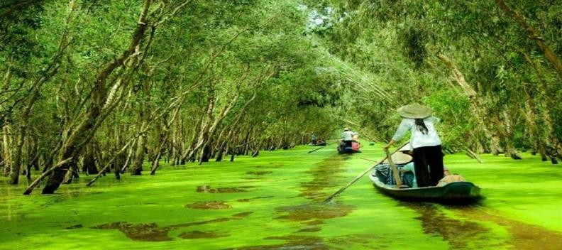

Enjoy the scenic journey along the National Highway bordered by green rice fields. On arrived at My Tho, visit Vinh Trang pagoda, take a leisurely boat ride along the river, view the stilt houses, fruit plantations and fishing villages along the river bank. Proceed to Tortoise islet, have lunch in the orchard garden. Then a boat ride to An Khanh – a less touristy attraction in Ben Tre, enjoy cruising on a hand-rowed sampan under the shadow of the water coconut trees along natural canals, then enjoy
seasonal fruit and honey tea to the sound of "Southern Vietnamese folk music", performed by locals Visit a family business which epitomizes the idyllic rural lifestyle, taste the delicious coconut candy and observe the pastoral life as you roam through the fruit plantation and village.
Overnight in Hochi Minh City

Day 7: City tour + Lunch + Fly to India (BL)
- Reunification Hall

-Notre Dame Cathedral-

-General Post Office

-City Hall

- War Remnants in Viet Nam Museum (War Crime Museum).
- After that Drop to the Airport.

