DISCOVERY TOUR OF SRI LANKA 5 NIGHTS / 6 DAYS
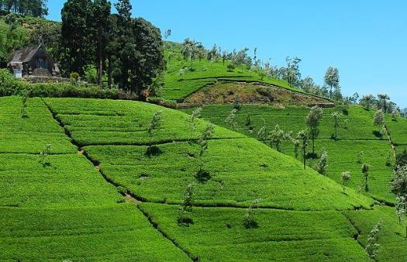
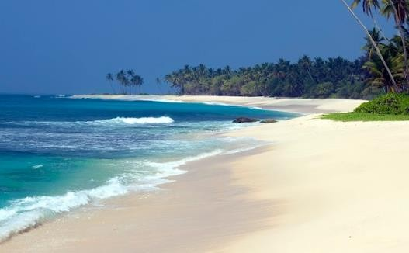
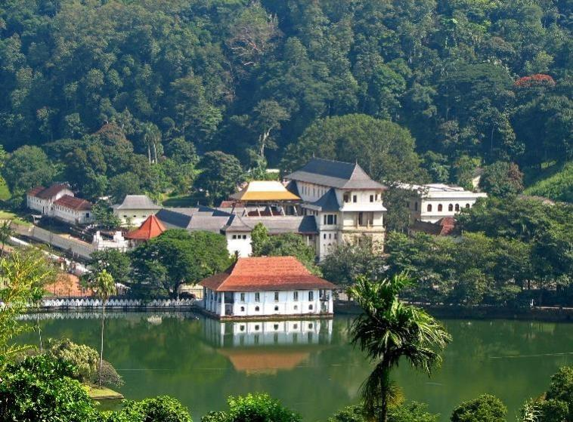
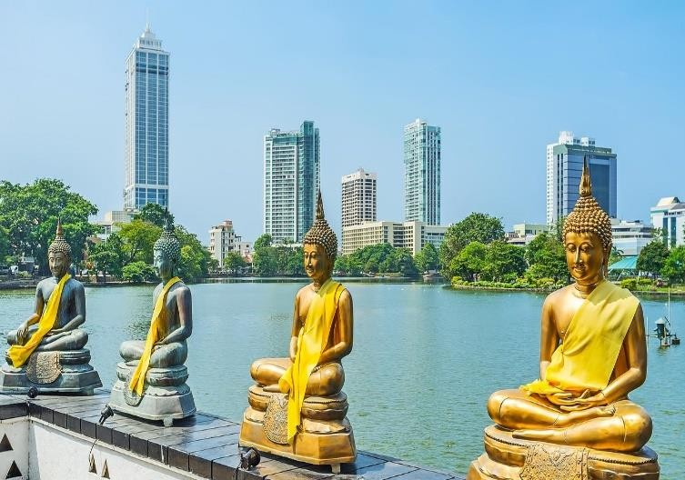

DAY 01 AIRPORT - COLOMBO
Arrival in Sri Lanka Morning.

Arrive in Sri Lanka. Clients will be met and welcomed by representative of Topical Asia Tours with Galant
Proceed to Colombo

COLOMBO CITY TOUR (The excursion will take approx. 3 hrs)
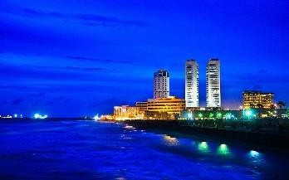
Colombo is the business and commercial center and the new capital is Sri Jayawardhanapura Kotte, only a few miles away. Colombo was only a small seaport, which came into prominence in the 16th Century with the arrival of the Portuguese in 1505 and the development of it as a major Harbor took place during the British period. Colombo became the capital of Sri Lanka in 1815 after
Kandyan Kingdom was ceded to the British. The remains of the buildings during the period of the Portuguese, Dutch and British rule are found in every area of the city. None of the Portuguese & Dutch fortifications are found today but some of their buildings and churches could be seen in the Fort & Pettah areas. Visit Fort, the former British administrative center and military garrison, Sea Street - the Goldsmith’s quarters in the heart of Pettah, the Bazaar area where there is also a Hindu Temple with elaborate stone carvings, the Kayman’s Gate with the Belfry at the original gate to enter the Fort, the Dutch Church of Wolfendhaal dating back to 1749, Colombo Museum (There is an entrance fee of US$ 6/- Per person for the Museum) and the Natural History Museum are some of the sites which you can visit..

GANGARAMAYA TEMPLE (Entrance Not Include)
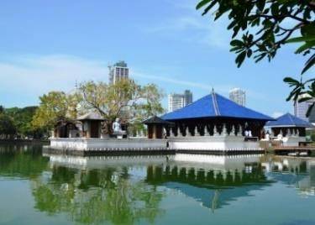
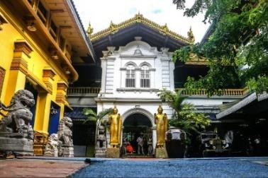
Gangaramaya Temple is one of the most important temples in Colombo. It was completed in the late 19th century. The temple's architecture demonstrates an eclectic mix of Sri Lankan, Thai, Indian, and Chinese architecture. This Buddhist temple
includes several imposing buildings and is situated not far from the placid waters of Beira Lake on a plot of land that was originally a small hermitage on a piece of marshy land. It has the main features of a Vihara (temple), the Cetiya (Pagoda) the Bodhi tree, the Vihara Mandiraya, the Seema malaka (assembly hall for monks) and the Relic Chamber. In addition, a museum, a library, a residential hall, a three storied Pirivena, educational halls and an alms hall are also on the premises. Most notable for tourists is the architecture of the Seemamalaka Shrine, which was built with donations from a Muslim sponsor to the design of Geoffrey Bawa.

Check in to hotel in Colombo

Overnight stay at Colombo Hotel (4*)

DAY 02 COLOMBO – DAMBULLA
After Breakfast Proceed to Dambulla En route Visit

PINNAWALA ELEPHANT ORPHANAGE (Entrance Not Include)
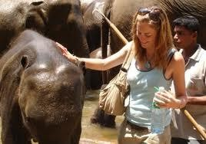
Situated 55 miles from Colombo, off the Colombo - Kandy road is Pinnawala, where an orphanage was started in 1975 to house the abandoned and the wounded elephants. The number of elephants has increased to more than 65 now, including Baby Elephants brought from various parts of Sri Lanka, as well as more than 25 babies born as a result
of the captive breeding program. The best time to visit is the feeding time from 09.15-10.00 hrs. And 13.30-1400 hrs. and the bathing time from 10.00-1030 hrs. and 14.00-1430 hrs. when all the elephants are taken to the river close by.

Thereafter proceed to Dambulla

SIGIRIYA (The excursion will take approx. 3 hrs) (Entrance Not Include)
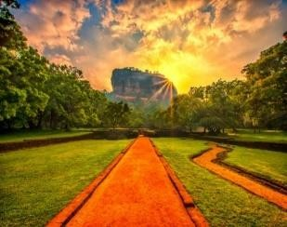
Sigiriya is a “World Heritage Site” which is built in the 5th Century and known as the “Fortress in the Sky” which is perhaps the most fantastic wonder of the Island. It is also known as Lion Rock because of the huge lion that used to stand at the entrance to the Palace on the summit of the 600-foot high rock.
On its summit are the foundations of the Royal Palace, Water Tanks to supply water and all other buildings and at the edges the guardhouses. On one of the stairways the only known ancient work of Sinhala secular painting survived in the form of Frescoes of 21 life sized damsels still shining in their original colors. This magnificent creation is preserved as a UNESCO Heritage and also known to be the Eighth World Wonder.

DAMBULLA (The excursion will take approx. 2 hrs) (Entrance Not Include)
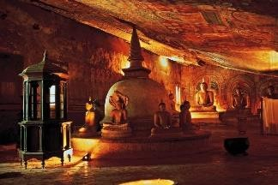
Dambulla Cave is a vast isolated rock mass 500 feet high and a mile around the base. Within these rock columns you find the Dambulla Cave Temple which is one of the UNESCO World Heritage sites in Sri Lanka. The Caves of Dambulla sheltered King Walagamba during his 14 years of exile from Anuradhapura. When he regained the throne he built the most magnificent of Rock Temples to be found in the Island. In the first Cave is a recumbent
image of the Buddha 47ft long cut out of the Rock. There are images of deities associated with Buddhism all around. The frescoes on the walls and the ceiling are the oldest here but they are over painted in the Kandy period. In the Second Cave, the finest and the largest of all, there are 150 life- size statues of the Buddha in various postures with few statues of Gods and Kings. The ceiling is also covered with frescoes, which depict great events in the life of the Buddha and landmarks in the history of the Sinhalese people.

Overnight stay at Dambulla Hotel (4*)

DAY 03 DAMBULLA - KANDY
After Breakfast Proceed to Dambulla

SPICE GARDENS SRI LANKA (The excursion will take approx. 2 hrs)
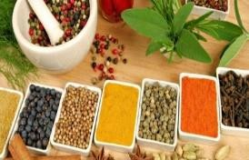
You will see many spice gardens at Matale (en-route Dambulla -Kandy) and in Mawanella on the Colombo-Kandy Road where Cinnamon, Cardamom, Pepper Creepers and all other spice trees, plants and creepers are planted for visitors to see them. Spice products are also available for those who would like to buy them.
At all Spice Gardens visitors are taken round explaining each tree and plant and at the end explaining the use of them in food preparations.

Thereafter Visit Kandy

KANDY TEMPLE VISIT (The excursion will take approx. 2 hrs) (Entrance Not Include)
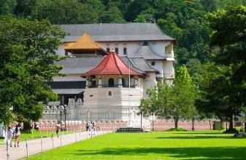
The hill capital is another “World Heritage Site”. It was the last stronghold of the Sinhalese Kings during the Portuguese, Dutch and British rule and finally ceded to the British in 1815 after an agreement. To the Buddhists of Sri Lanka and the World, Kandy is one of the most sacred sites as it is the home of the “Dalada Maligawa” - Temple of the Sacred Tooth Relic of Lord Buddha.

GEMS OF SRI LANKA (The excursion will take approx. 1 hr)
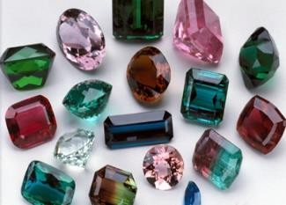
The world’s best gems are available in Sri Lanka such as Blue and Yellow Sapphire, Star Ruby and Star Sapphire, Chrysoberyl Cat’s Eye, Alexandrite, Topaz, Amethyst, Quartz, Garnet, Aquamarine, Moonstone and Tourmaline. When comparing with other countries you will be lucky to buy pure and valuable gems at Sri Lanka for a competitive price. You can get the education about gems, making jewelries and other requests with them. You can buy gold, white gold and silver jewelry at your
choice. You can even get them Tailor Made as per your preference.

Evening Kandy Cultural Dance Visit (Combine visit with Gem Shop and Gem Museum only)

Check in to Hotel

Overnight stay at Kandy Hotel (4*)

DAY 04
KANDY- NUWARA ELIYA
After breakfast Proceed to Nuwara Eliya

En Route Visit

TEA PRODUCTION IN SRI LANKA (The excursion will take approx. 1 hr.)
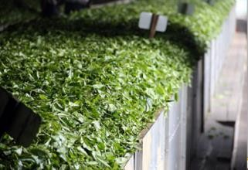
The industry was introduced to the country in 1867 by James Taylor, the British planter who arrived in 1852. Since then, Sri Lanka is the world's fourth largest producer of Tea and the industry is one of the country's main sources of foreign exchange and a significant source of income for laborers, with tea
accounting for 15% of the GDP, generating roughly $ 700 million annually. In 1995, Sri Lanka was the world's leading exporter of Tea, (rather than producer) with 23% of the total world export. The Tea sector employs, directly or indirectly over 1 million people in Sri Lanka and in 1995 directly employed 215,338 on Tea plantations and Estates. The humidity, cool temperatures, and rainfall in the country's central highlands provide a climate in favor to the production of high-quality Tea Check in at hotel.
LOVERS’ LEAP WATERFALLS

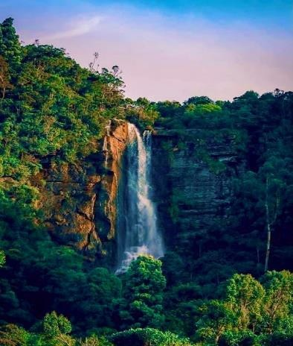
Lovers' Leap Waterfalls of Nuwara Eliya is a beautiful cascading falls that is situated near the city of Nuwara Eliya in Sri Lanka. It is situated close to a tea plantation and is surrounded by lush green hills. The cascading waterfalls and its various levels make the whole view a very pleasing one. This waterfalls creates a great ambience for a romantic time and it is frequently visited by newlywed couples. Visitors can also enjoy swimming in the large pool at the bottom of the falls. There are also some picturesque spots nearby, such as the Lover's Leap Bridge, where visitors can enjoy the amazing views of the waterfall from above. There is also a small shrine near the pathway to the falls to honor the romantic Hindu legend associated with it.

Thereafter Reach Nuwara Eliya
NUWARA ELIYA (The city tour will take approx.: 1-2 hrs.)
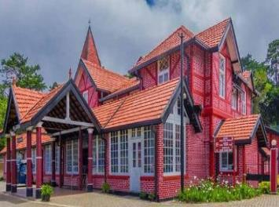
The ‘Little England’ of Sri Lanka, is set against beautiful backdrops of Mountains, Valleys, Waterfalls and Tea Plantations. It is supposed to be one of the coolest places in the Island, but it is really just like an English spring d ay, although the temperature does drop at night. All around Nuwara Eliya you will see evidence of the British influence, houses like country cottages or Queen Ann style mansions. The Victoria Park, in the middle of the town, is a lovely
place for a stroll or a picnic and is also good for Birding as you get some rare birds in this Park. Seasons may be absent elsewhere in Sri Lanka, but here you can read them by the flowers, which bloom in the spring (March to May) and the fall (August and September). These are the “seasons” when low-country folk flock to Nuwara Eliya to escape the sea level heat and humidity.

GAYATHRI PEEDAM NUWARA ELIYA
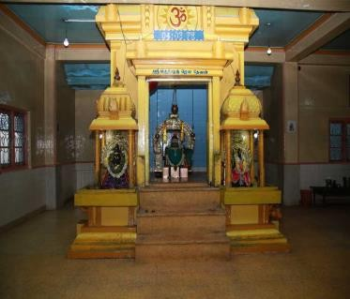
Gayathri Siddhar Swami Murugesu is the founder of Sri Lankatheeswarar temple in 1974 with his sole efforts. The Sri Lankatheeswarar temple is the first and the foremost temple built for Gayathri Amman in Sri Lanka, and the Shiva Lingham installed in this temple was brought from the holy river Narmada by Sri
Sivabalayogi Maharaj. This temple has showered with endless blessings of Siddhars especially Gayathri Siddhar Swami Murugesu. Swami MurugesuHe had an ashram next to the temple and lived next to the ashram. There was also a block of sandy steps leading up to a big hall, where Murugesu conducted yagnas and did rituals for Poya day. In the temple there was a big Shivalingam, that would have
an abishekam every month. There is a black statue of Goddess Gayathri is there opposite to the temple.

SITA AMMAN KOVIL (The excursion will take approx. 1/2 hr)
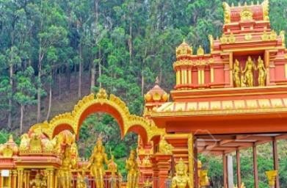
According to the Indian Epic Ramayanaya and the legends, the area where Sita, Queen of King Rama of Ayodhya in India, who was abducted by Ravana the King of Sri Lanka, was kept in hiding and the area she roamed is in the hill country of Sri Lanka. In Nuwara Eliya is the "Sita Amman Kovil" - a quaint little Kovil, with the statues of Rama, Sita, Hanuman, Lakshmana and Sugriva. This is supposed to be the only
Kovil in the entire World dedicated to Sita. The stream by the side of the Temple is a famous spot where she went for bathing. Out of the 13 Palaces of Ravana, two caves in the Strict Nature Reserve of Hakgala, starting from Temple land and the cave at Ella close to the waterfall "Ravana-Ella" (1080ft. high) where Ravana went for bathing, are supposed to be three Palaces Sita was kept in hiding. The Hakgala Gardens may be the "Ashok Vanaya" of Ramayana where Rhododendrons identified as Ashok Flowers in the epic, are found in bloom throughout the year.
Overnight stay at Nuwara Eliya Hotel 4*
DAY 05
NUWARA ELIYA – BENTOTA

After breakfast proceed to Bentota

BENTOTA

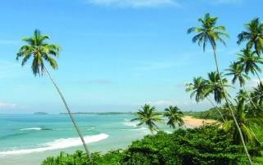
Geoffrey Bawa

Bentota is a resort town on Sri Lanka’s Southwest coast. Its long Bentota Beach stretches north, where it becomes a sandy strip known as Paradise Island, parallel to Bentota Lagoon. Coral-rich dive sites include Canoe Rock. On Bentota River, centuries-old Galapota Temple has a large Buddha statue. Southeast is Lunuganga, the estate and gardens of architect

Visit Ambalantota Mask making Factory

AMBALANGODA (The excursion will take approx. 1 hr)
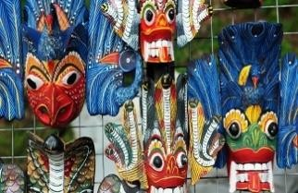
Ambalangoda is a charming town, most famous for its “devil- dancers” and mask carvers. You will be fortunate to encounter an actual bali (exorcist) or kolam (folk drama) performance, as these are not performed especially for
visitors. On the other hand, if you do manage to attend a ceremony, you can be assured that it is the real thing. The masks of bright colors are created based on the “authentic” masks used for curing patients suffering from 18 types of ailments (Sanni) they suffer.

KOSGODA TURTLE HATCHERY (The excursion will take approx. 1 hr) (Entrance Not Include)
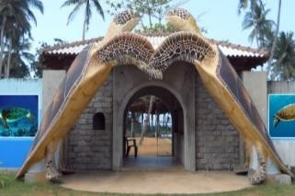
The Kosgoda Turtle Hatchery is the place where you can see five species of turtles who are known to be facing the threat of extinction -Green Turtles (Chelonia mydas), Hawksbill Turtle (Eretmochelys imbricata), Loggerhead Turtle (Caretta caretta), Leatherback Turtle (Dermochelys coriacea) and Olive Ridley Turtle (Lepidochelys olivacea).
The eggs collected by the Villagers and Fishermen are purchased by the Kosgoda Hatchery and kept in sandy pens until they are hatched. The newly hatched ones are kept in seawater tanks and released to the sea in the night. This Hatchery alone has released more than 1,750,000 young turtles to the sea. An endowment by the Hasselblad Estate was responsible for the establishment of this hatchery.

Check in at the Hotel

Overnight stay at Beach Hotel 4*
DAY 06 BENTOTA – AIRPORT

breakfast at the hotel

Thereafter, check out from the hotel & proceed to airport for Departure.

Departure Time from Sri Lanka – After Noon

---END OF PROGRAME---

