ENCHANTING ARMENIA
05 Nights & 04 Days

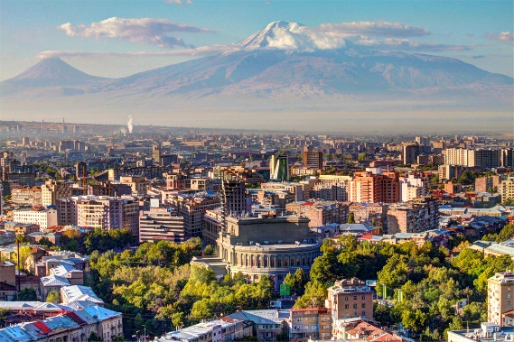
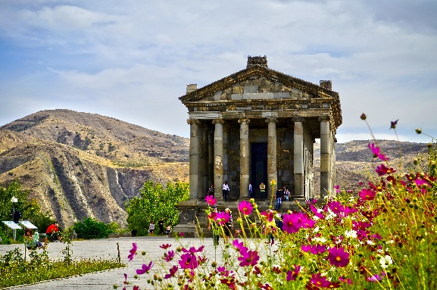
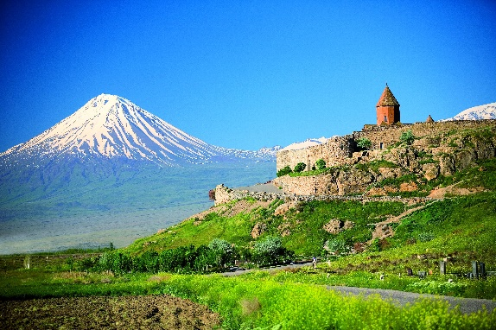

Day 1: Arrival

Arrival at Zvartnots International Airport. Meet and greet transfer to the hotel. Overnight in Yerevan

Day 2:Yerevan City tour/Garni / Geghard/

Start exploring Yerevan which is also named “Pink City” for buildings with pink color which gives the stone “tufa”. It’s an old and ancient city therewith considered also a modern and splendid city. Start your tour from Republic Square which was build 1950s by the project of Tamanian 20 years of after his death. Walking through the Northern Avenue, which is the modern part of the capital and considers to be the heart of Yerevan. Afterwards we are next to Opera House and Swan Lake where we can have photo stop. Continue to Cascade monument which is an open-air museum. Climbing up the stairs you will enjoy the fascinating view of Yerevan. Walking through memorial park and stop by the Mother Armenia Monument.departure to Geghard Monastery (13th c.) – a monastery which is hewn out from a cave. The monastery had been originally named Ayrivank meaning "the Monastery of the Cave". The name commonly used for the monastery today, Geghard, or more fully Geghardavank meaning "the Monastery of the Spear". The monastery is also included in the UNESCO World Heritage list.
Continue our journey to Garni Pagan Temple from 1st c. The temple was built by Armenian King Tiridates and was dedicated to the God of Sun Mithra. Garni is the only Hellenistic temple existing nowadays in Armenia. The stairs of the temple are made huge and high which means that every human being climbing up the stairs is condescending to God of Sun
Back to capital. Overnight in Yerevan.

Day 3: Yerevan-Khor Virap-Areni-Noravank- Yerevan

Today we are going to learn more about the historical treasures of Armenia by driving to Ararat Valley to visit Khor Virap Monastery. The monastery of Khor Virap (3rd – 17th cc.) is located in the place of an ancient capital of Armenia –Artashat. The significance of the church is relatively connected with Grigor Illuminator who was spreading Christianity in Armenia
Continue our trip to one of the most important agricultural regions of Armenia – to VayotsDzor region. Afterwards, visit one of the local wineries in Areni village for homemade wine degustation.
Today’s cultural discovery will be Noravank Monastery - a spectacular monastic complex, surrounded with mountains, richly covered by red stones which give one the harmony of culture and nature. Return to Yerevan. Overnight at the hotel in Yerevan

Day 4: Yerevan-Tsaxkadzor-Sevan Lake-Yerevan

Departure to the resort town of Tsakhkadzor (Gorge of Flowers) – town of forested mountains. Walking tour around the city. Opportunity to ride up the ropeway which will take you to the peak of mount Teghenis from where opens breathtaking view to the forested town. The most popular season to visit Tsaghkadzor is winter because of the famous ski resort which is the biggest in Armenia and attracts tourists and professional athletes from all around the world for skiing and snowboarding. The road will take youtoday to Lake Sevan which is going to be one of the highlights if your trip. Climb the stairs up on the peninsula from where opens a fascinating view to the “blue-eyed” lake. Sightseeing tour on the peninsula. Lake Sevan is considered to be one of the largest sweet lakes in the world at an altitude of 1897 meters above sea level. Back to Yerevan.

Day5:Departure

Transfer to the airport. Departure home!

- Depending on weather conditions travel routes can be changed
- Rates are in USD per person sharing DBL room

PAX | 3*Comfort Hotel or similar in Yerevan | 4*President Hotel or similar in Yerevan | 4*Ani Plaza Hotel or similar in Yerevan
2 | 695 | 678 | 725

Rates include:

- Individual airport/hotel/airport transfer
- Transportation for sightseeing tours on private bases
- English speakingGuide/Driver
- 4 x nights’ accommodation in3* or4*Hotel in Yerevan
- Daily buffer breakfast at the hotel
- Entrance fee to sightseeing places
- 1x ropeway ticket in Tsaghkadzor
- 1 x wine degustation
- 2 bottle water per day per person
- Air tickets
- lunches
- Dinners
- Travel Insurance
- Alcoholic beverages
- Tips and portage

Rates do not include:

